IP address of a particular domain (guvi.in)
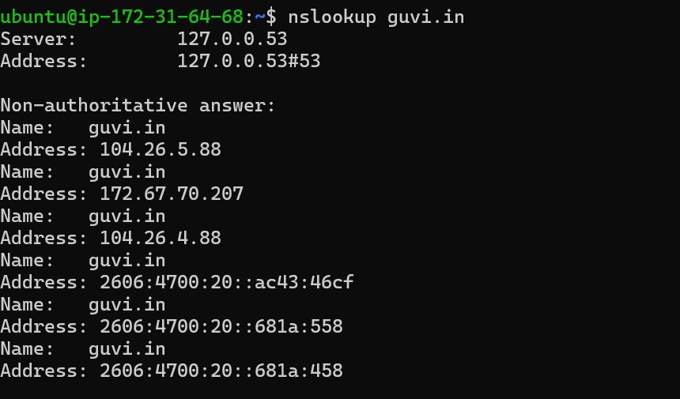

CPU/memory usage of my server
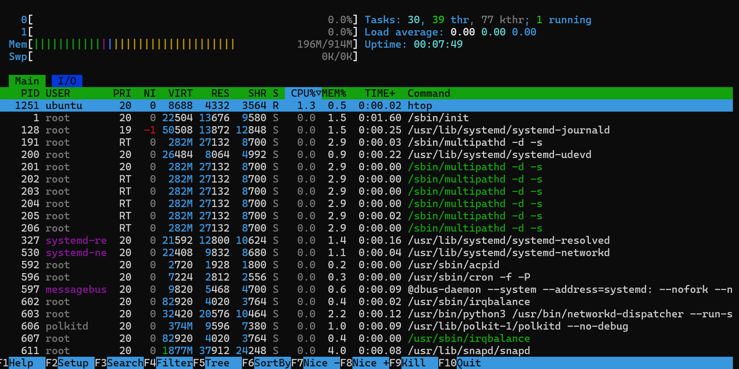

Test the connectivity between 2 nodes – connectivity between my server and guvi.in serverp
Using – ping command with guvi I.P
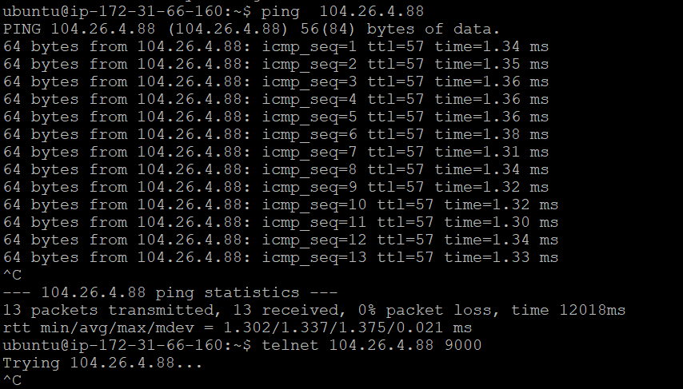

Using – dig and traceroute command
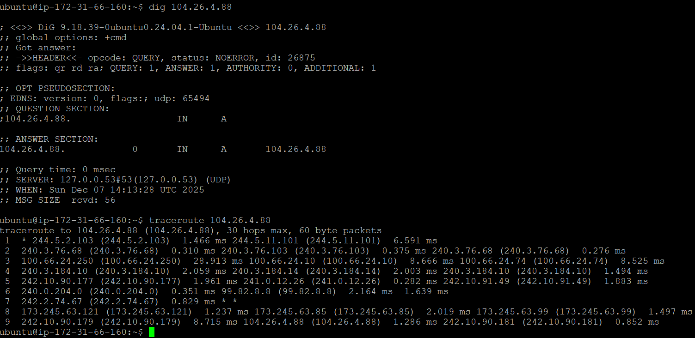

I have deployed an application in guvi.com:9000, and logs show my app is running, but I’m unable to view the page. Check whether my port is open or not:

->Using telnet command with port -9000 for guvi.com portal i.p which is not connected so port is not open.
